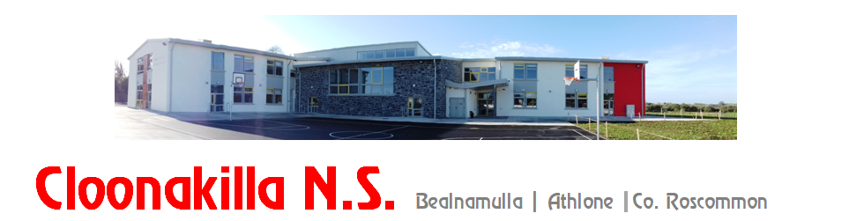

Phone: 090 6492569, email: [cloonakillaschool@gmail.com](mailto:cloonakillaschool@gmail.com), website: www.cloonakillans.com

**Late Application for Admission of New Pupils for Junior Infants 2025**

Surname of Child: ___________________________________First Name: __________________________

Date of Birth: ___________________

Home Address: ___________________________________________________________________________

Eircode: ______________________________

Parents’/Guardians’ Names: _______________________________________________________________________

Brothers/Sisters in Cloonakilla NS (if any):

__________________________________________________________________

Mother’s Mobile: ________________________________Email: ______________________________________

(Block letters please)

Father’s Mobile: _________________________________Email: ______________________________________

(Block letters please)

Parent’s /Guardians Signature: ____________________________________

Parent’s /Guardians Signature: ____________________________________

Date: ____________________________________